ACTIVITY 1
install.packages("readxl")
install.packages("reshape2")
install.packages("ggplot2")
library(readxl)
library(reshape2)
library(ggplot2)
data <- read_excel("StudentMarks.xlsx")
print(data)
heatmap_data <- melt(data, id.vars = "Student")
ggplot(heatmap_data,
aes(x = variable, y = Student, fill = value)) +
geom_tile(color = "white") +
geom_text(aes(label = value), size = 4) +
scale_fill_gradient(low = "yellow", high = "red") +
labs(title = "Heatmap of Student Marks",
x = "Subjects",
y = "Students") +
theme_minimal()
data$Total <- rowSums(data[,2:6])
data$Average <- rowMeans(data[,2:6])
highest <- data[which.max(data$Total), ]
cat("Highest Overall Performer:\n")
print(highest[, c("Student","Total","Average")])
subject_average <- colMeans(data[,2:6])
cat("\nAverage Marks in Each Subject:\n")
print(subject_average)
highest_subject <- names(which.max(subject_average))
cat("\nSubject with Highest Average:", highest_subject)
support_students <- data[data$Average < 70,
c("Student","Average")]
cat("\nStudents Needing Support:\n")
print(support_students)
cat("\nOverall Student Performance:\n")
print(data[, c("Student","Total","Average")])

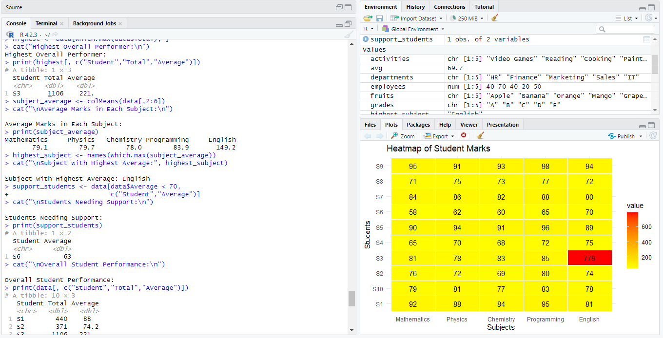

Advantages of a Heatmap
- Easy Data Visualization: A heatmap represents data using colors, making large datasets easier to understand at a glance.
- Quick Identification of High and Low Values: Different color intensities help quickly identify high-performing and low-performing students or subjects.
- Pattern Recognition: It reveals trends, similarities, and differences in student performance across multiple subjects.
- Easy Comparison: A heatmap allows simultaneous comparison of marks across all students and subjects without examining individual values.
- Supports Decision-Making: Teachers can easily identify students who need academic support and subjects where overall performance is weak or strong.
- Improves Data Interpretation: Color-coded visualization makes complex numerical data more intuitive and easier to interpret than traditional tables.
- Time-Saving: It enables users to analyze performance quickly without manually calculating or comparing values.
- Effective for Reporting: Heatmaps provide a clear and visually appealing way to present performance data in reports, presentations, and dashboards.
ACTIVITY 2
install.packages("readxl")
install.packages("reshape2")
install.packages("ggplot2")
library(readxl)
library(reshape2)
library(ggplot2)
data <- read_excel("Employees.xlsx")
print(data)
salary_data <- melt(data, id.vars = "Employees")
ggplot(salary_data,
aes(x = variable, y = value, fill = variable)) +
geom_violin(trim = FALSE) +
geom_boxplot(width = 0.1, fill = "white") +
labs(title = "Violin Plot of Employee Salaries",
x = "Department",
y = "Salary") +
theme_minimal()
ggplot(salary_data,
aes(x = variable, y = value, fill = variable)) +
geom_boxplot() +
labs(title = "Boxplot of Employee Salaries",
x = "Department",
y = "Salary") +
theme_minimal()
variation <- apply(data[,2:5], 2, sd)
cat("Standard Deviation:\n")
print(variation)
largest_variation <- names(which.max(variation))
cat("\nDepartment with Largest Variation:", largest_variation)
median_values <- apply(data[,2:5], 2, median)
cat("\nMedian Values:\n")
print(median_values)
highest_median <- names(which.max(median_values))
cat("\nDepartment with Highest Median:", highest_median)
cat("\nConclusion:\n")
cat("Violin plot better represents the distribution because it shows the\n")
cat("shape (density), spread, and median of the data, while a boxplot\n")
cat("shows only the median, quartiles, and possible outliers.\n")
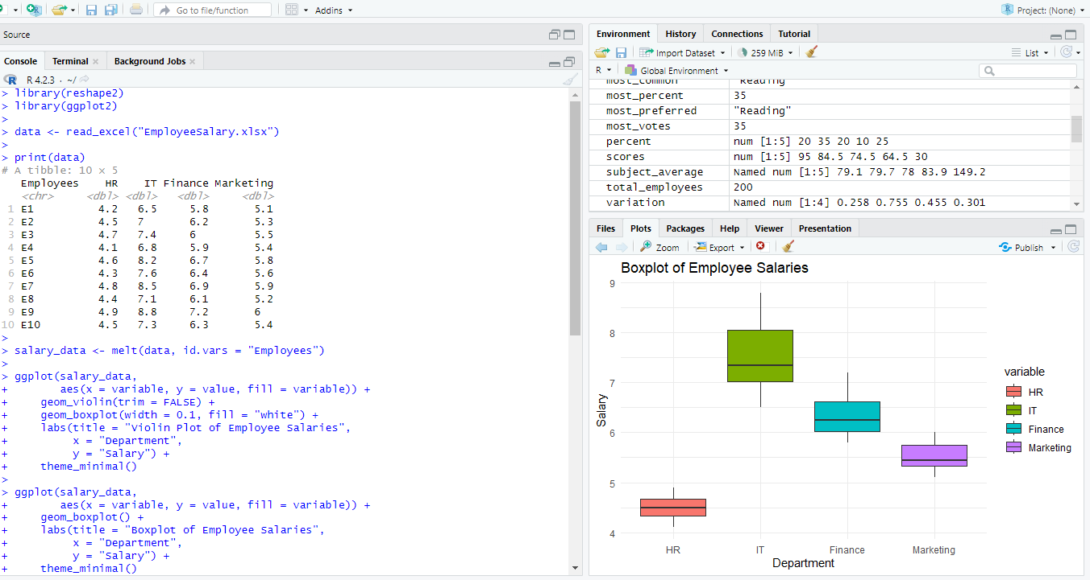
Which plot better represents distribution?
Answer: Violin Plot better represents the distribution.
Explanation:
A violin plot provides more detailed information about the distribution of the data because it combines a boxplot with a density plot. It shows:
- The shape (density) of the data distribution.
- The median and interquartile range (IQR).
- The spread and variability of the data.
- Whether the data is skewed or has multiple peaks (multimodal).
In contrast, a boxplot only summarizes the data by displaying the median, quartiles, whiskers, and any outliers. It does not show the actual distribution shape.
Conclusion:
The violin plot better represents the distribution because it displays both the summary statistics and the underlying density of the data, providing a more comprehensive view than a boxplot.
ACTIVITY 3
library(readxl)
library(moments)
data <- read_excel("C:/Users/YourName/Documents/responsetime.xlsx")
print(data)
response_time <- data$`Response Time(ms)`
hist(response_time,
main = "Histogram of Response Time",
xlab = "Response Time (ms)",
col = "lightblue",
border = "black")
plot(density(response_time),
main = "Density Plot of Response Time",
xlab = "Response Time (ms)",
col = "blue",
lwd = 2)
sk <- skewness(response_time)
cat("Skewness =", sk, "\n")
if(sk > 0){
cat("Distribution: Positively (Right) Skewed\n")
} else if(sk < 0){
cat("Distribution: Negatively (Left) Skewed\n")
} else {
cat("Distribution: Symmetric\n")
}
Q1 <- quantile(response_time, 0.25)
Q3 <- quantile(response_time, 0.75)
cat("Common Range (Middle 50%):", Q1, "to", Q3, "ms\n")
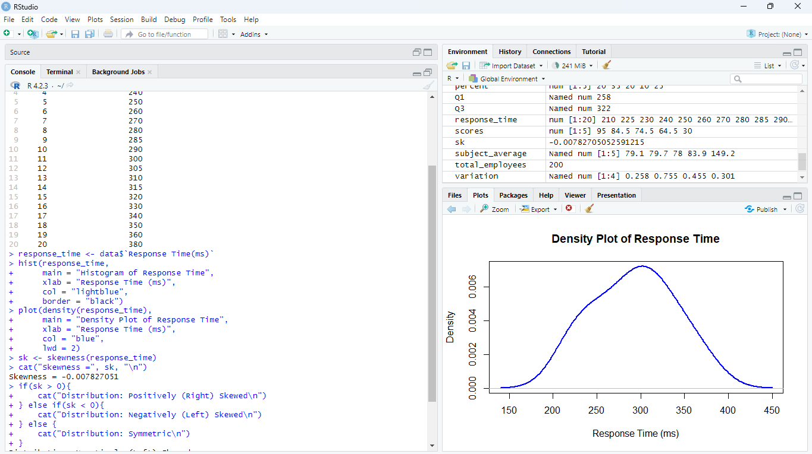

5. Which Plot Better Represents the Distribution?
Density Plot
Reason:
- Gives a smooth estimate of the distribution.
- Easier to identify the shape.
- Less affected by the choice of histogram bin width.
- Better for comparing multiple datasets.
Histogram is useful for seeing frequencies, while the density plot better illustrates the overall distribution.

Conclusion
The response times are distributed fairly evenly with a concentration between 260 ms and 330 ms. The skewness is very close to zero, indicating an almost symmetric distribution with a slight right tail. While the histogram effectively displays the frequency of observations, the density plot provides a smoother and clearer representation of the overall distribution, making it the better choice for visualizing this dataset.
ACTIVITY 4
# Install packages (Run only once)
install.packages("readxl")
install.packages("tidyr")
install.packages("dplyr")
install.packages("ggridges")
library(readxl)
library(tidyr)
library(dplyr)
library(ggridges)
data <- read_excel("Elwectricity.xlsx")
long_data <- pivot_longer(data,
cols = Jan:May,
names_to = "Month",
values_to = "Value")
ggplot(long_data,
aes(x = Value, y = Month, fill = Month)) +
geom_density_ridges(alpha = 0.7) +
labs(title = "Ridgeline Plot of Monthly Values",
x = "Value",
y = "Month") +
theme_ridges()
avg_month <- long_data %>%
group_by(Month) %>%
summarise(Average = mean(Value))
print(avg_month)
highest <- avg_month[which.max(avg_month$Average), ]
cat("\nHighest Average Month:\n")
print(highest)
spread <- long_data %>%
group_by(Month) %>%
summarise(Std_Dev = sd(Value))
print(spread)
widest <- spread[which.max(spread$Std_Dev), ]
cat("\nMonth with Widest Spread:\n")
print(widest)
cat("\nTrend:\n")
cat("The monthly values generally increase from January to May.\n")
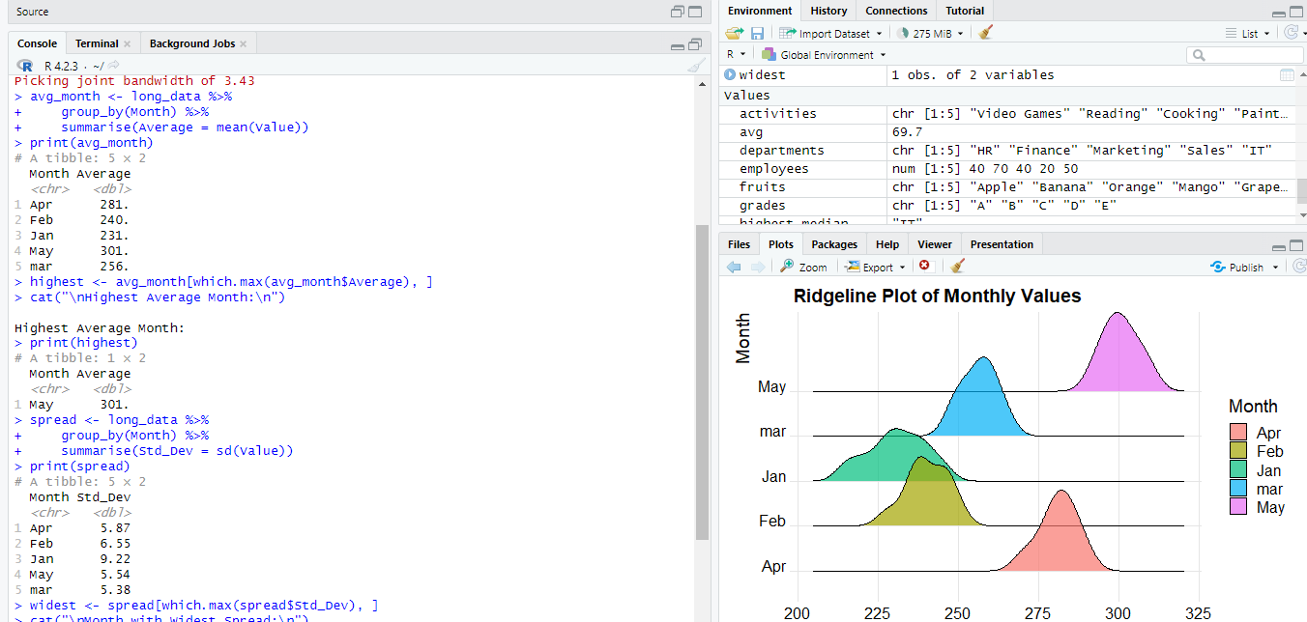

4. Describe Trend
Answer:
The data shows a steady upward trend from January to May. The average values increase consistently each month, indicating that the measurements for all houses generally improve over time. There are only minor variations among houses, but the overall pattern is a gradual increase.

5. Why Ridgeline?
Answer:
A ridgeline plot is used because it displays the distribution of values for multiple groups (months) in a single graph. It makes it easy to compare distributions, observe shifts in values over time, identify overlaps, and detect changes in variability across months.

Conclusion
The ridgeline plot effectively visualizes and compares the distribution of values across all months. The analysis shows a consistent increasing trend from January to May, with May having the highest average value and the widest spread, indicating greater variability during that month. Overall, the data demonstrates steady growth over time, and the ridgeline plot provides a clear and efficient way to compare monthly distributions and observe changes in both central tendency and variability.

ACTIVITY 5
library(readxl)
data <- read_excel("DailySTEPS.xlsx")
print(data)
age20_30 <- data$`20-30`
age31_45 <- data$`31-45`
age46_60 <- data$`46-60`
par(mfrow = c(1,3))
hist(age20_30,
main = "Histogram (20-30)",
xlab = "Income",
col = "lightblue")
hist(age31_45,
main = "Histogram (31-45)",
xlab = "Income",
col = "lightgreen")
hist(age46_60,
main = "Histogram (46-60)",
xlab = "Income",
col = "lightpink")
par(mfrow = c(1,1))
plot(density(age20_30),
main = "Density Curves",
xlab = "Income",
col = "blue",
lwd = 2)
lines(density(age31_45),
col = "red",
lwd = 2)
lines(density(age46_60),
col = "darkgreen",
lwd = 2)
legend("topright",
legend = c("20-30","31-45","46-60"),
col = c("blue","red","darkgreen"),
lwd = 2)
boxplot(age20_30,
age31_45,
age46_60,
names = c("20-30","31-45","46-60"),
col = c("lightblue","lightgreen","lightpink"),
main = "Boxplots of Age Groups",
ylab = "Income")
medians <- sapply(data[, c("20-30", "31-45", "46-60")], median)
print(medians)
Highest_median<- names(which.max(medians))
cat("Highest Median Group:", highest_median, "\n")
cat("Median Value:", max(medians), "\n")
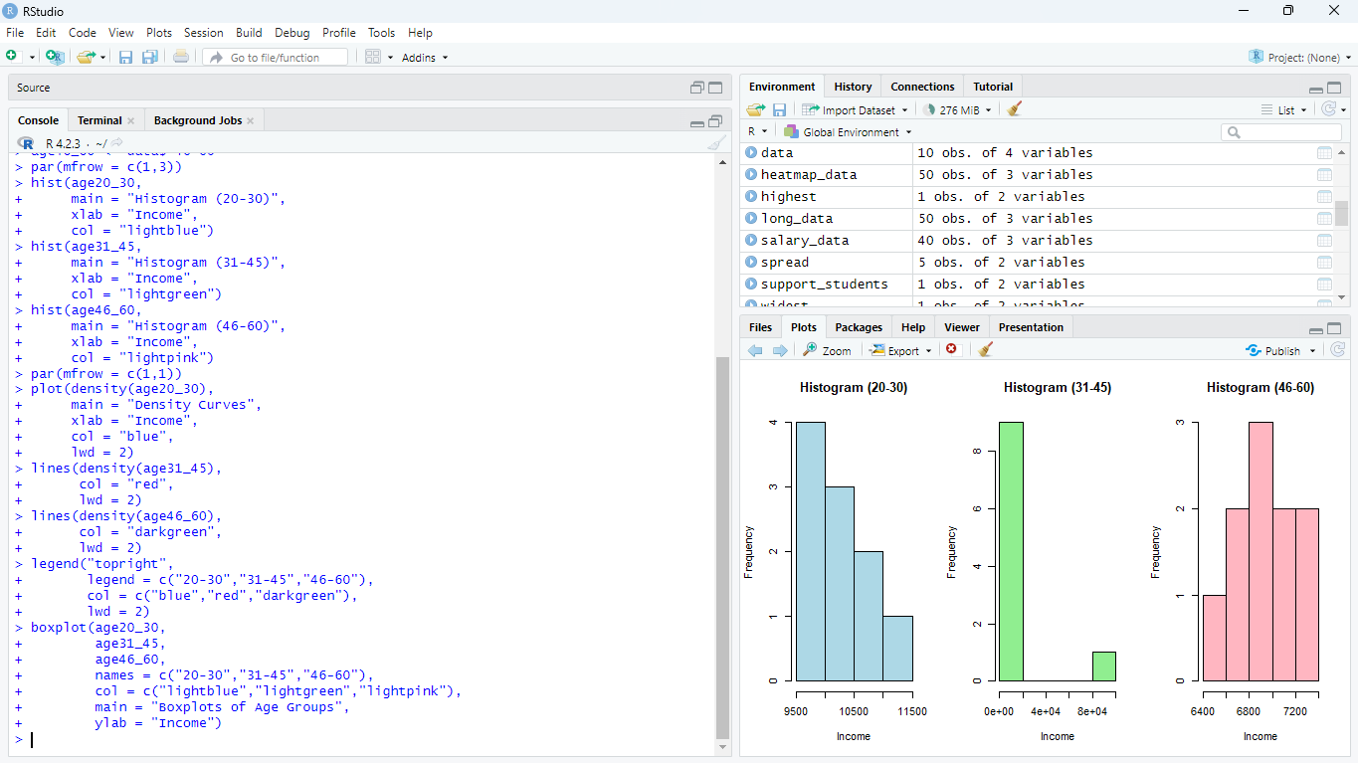

5. Best Visualization and Justify
Answer:
The Boxplot is the best visualization because it provides a concise summary of each age group's distribution. It clearly shows the median, interquartile range (IQR), overall spread, and any outliers, making it easy to compare the three groups simultaneously. While histograms and density plots illustrate the shape of the distribution, boxplots are more effective for comparing central tendency and variability across multiple groups.

Conclusion
The analysis indicates that the 20–30 age group has the highest median income, followed by the 31–45 and 46–60 groups. Histograms and density curves help visualize the distribution of incomes, while the boxplot provides the clearest comparison of the three groups by highlighting their medians, variability, and spread. Overall, the income values show a decreasing trend with increasing age in this dataset, and the boxplot is the most informative visualization for comparing these distributions.

